Setup: Employees and Departments Tables
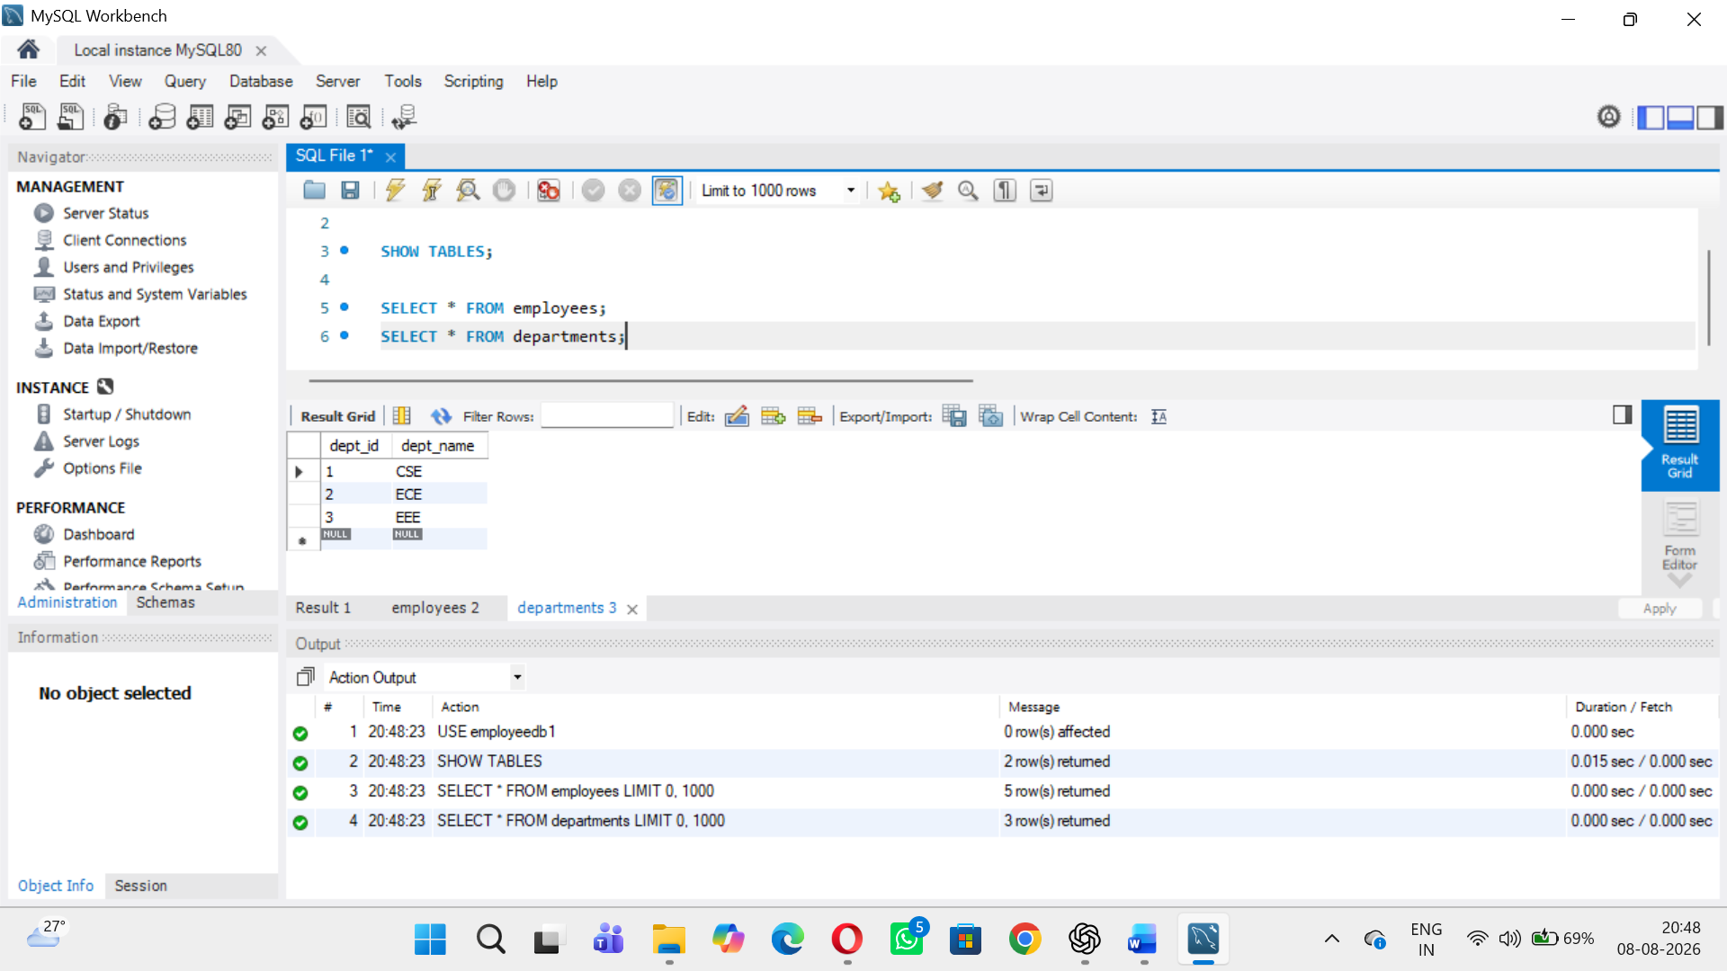
Verify the Tables
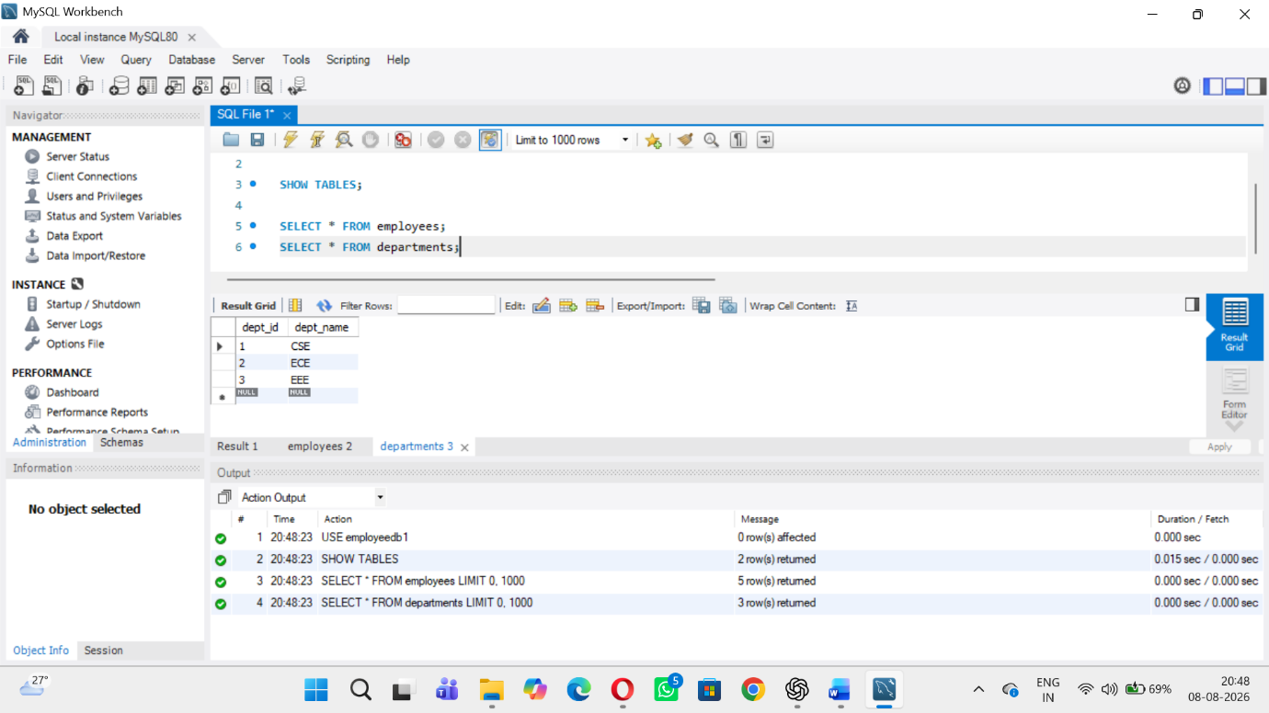
View 1 – Display All Employees
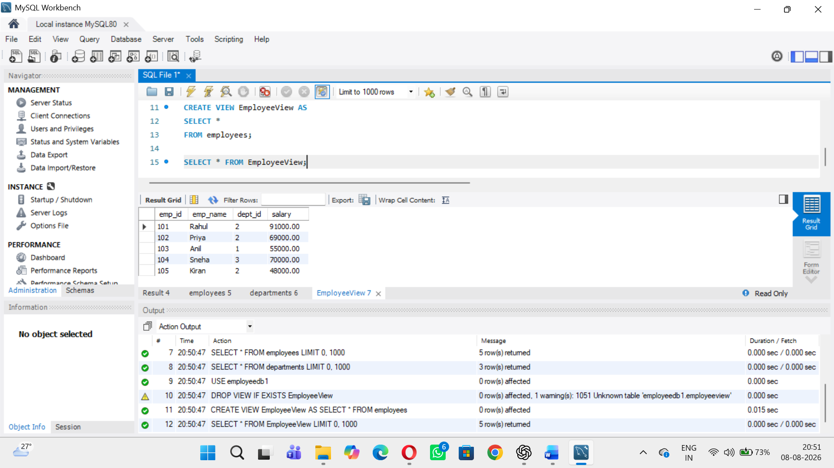
View 2 – Selected Columns
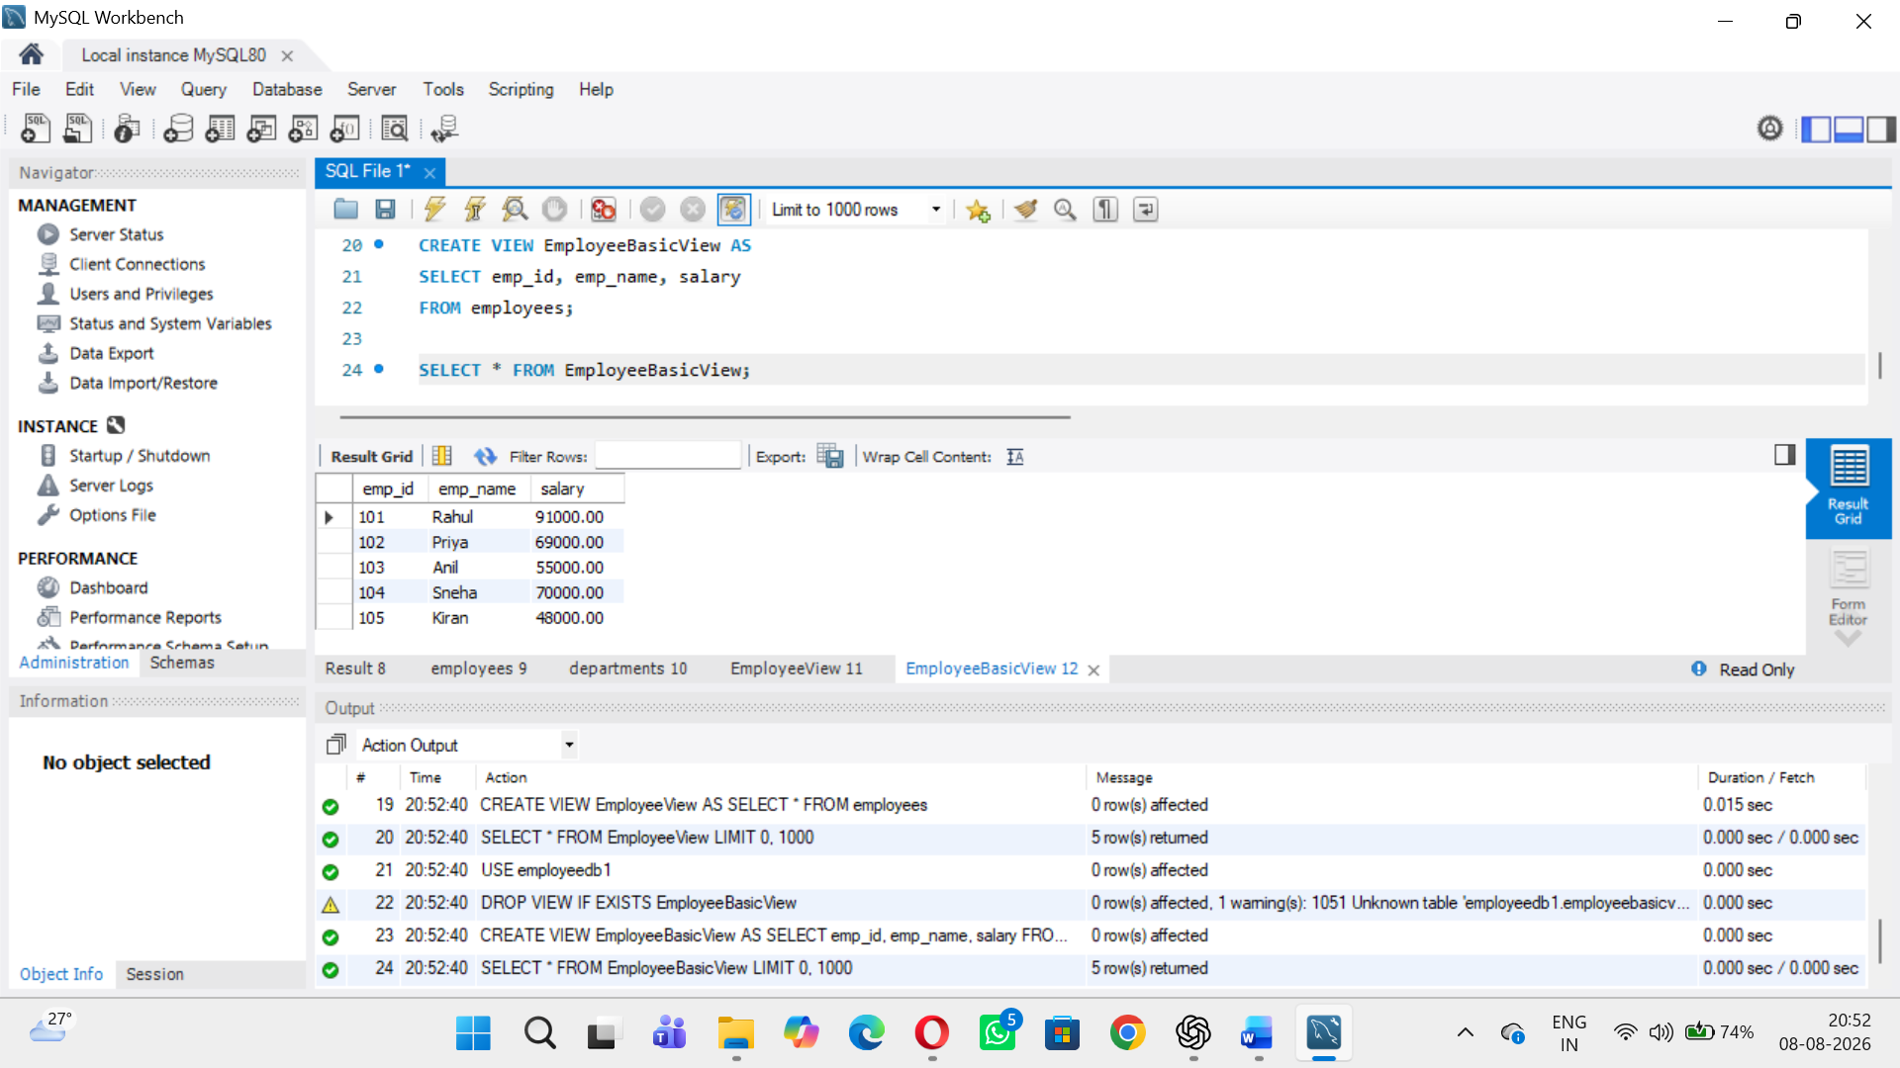
View 3 – High Salary Employees
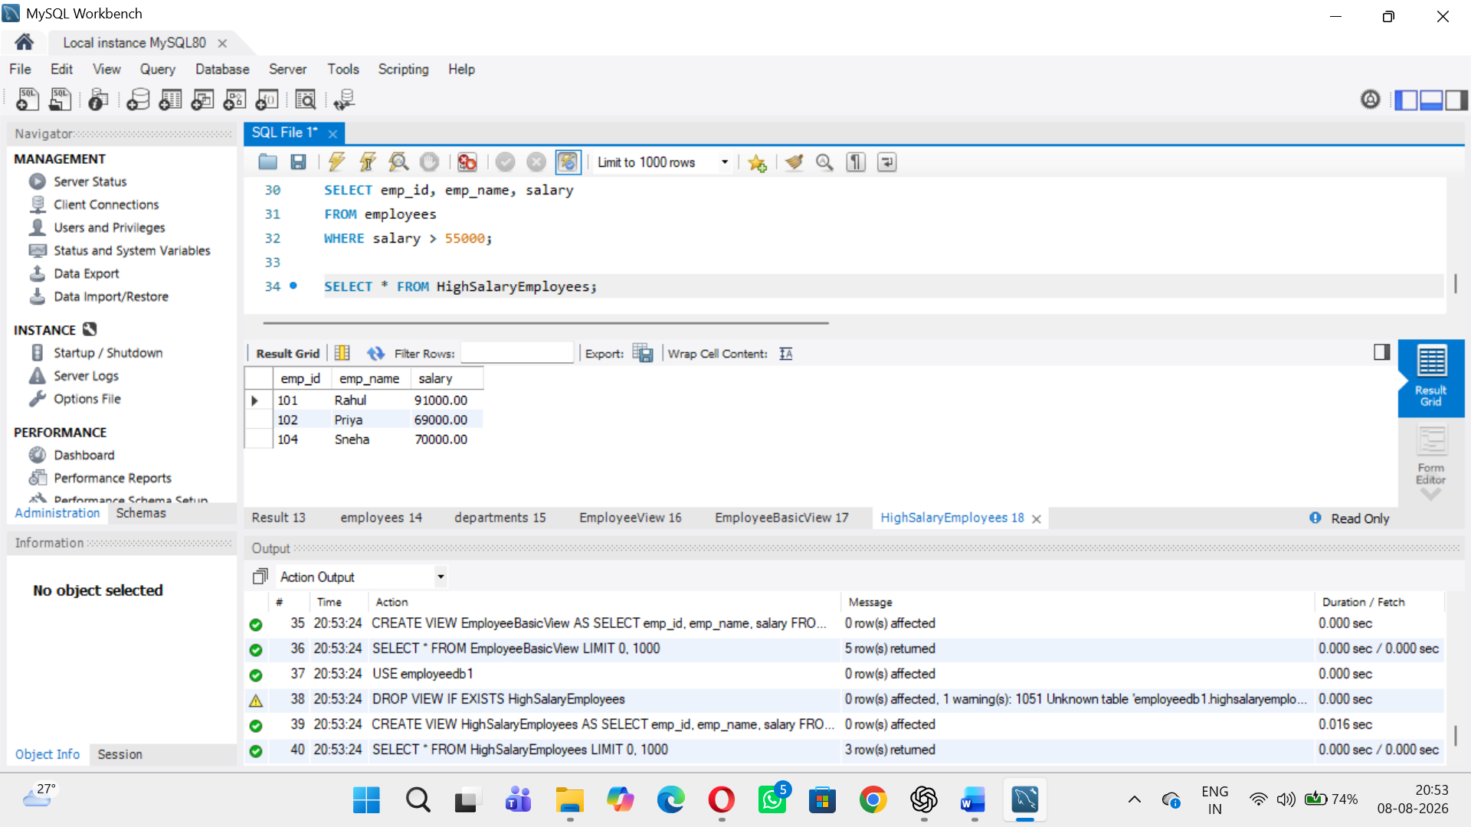
View 4 – Employee and Department using JOIN
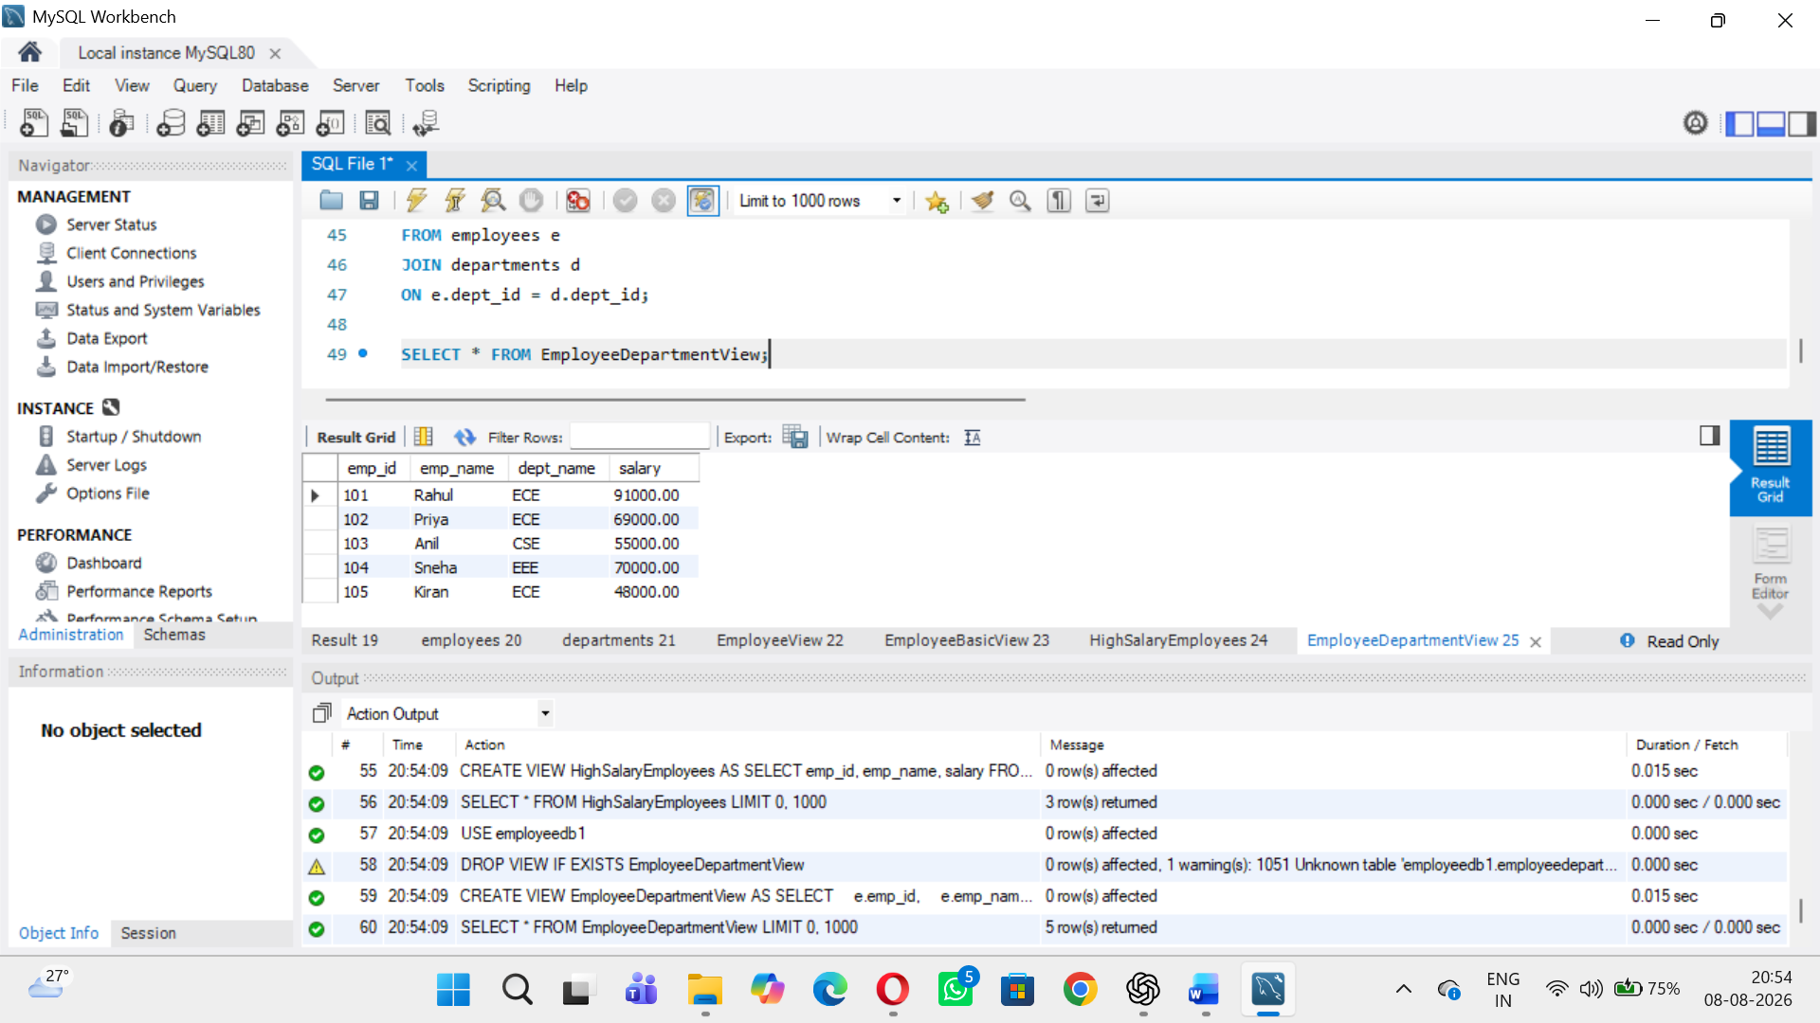
View 5 – Employees from a Particular Department
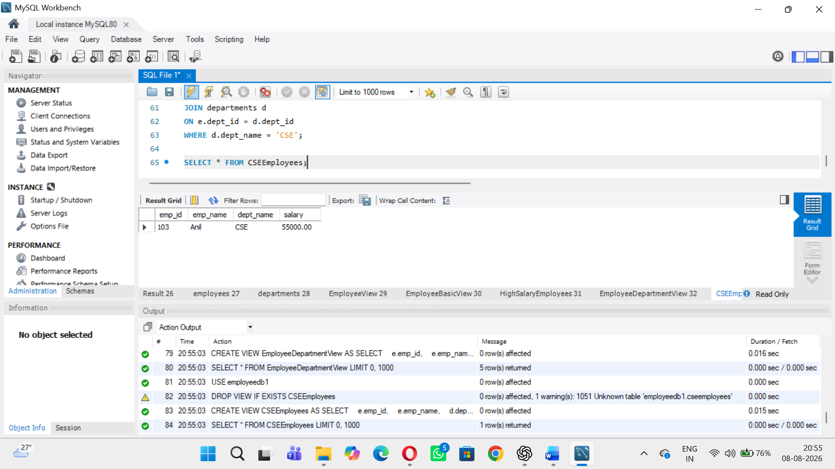
View 6 – Department-wise Average Salary
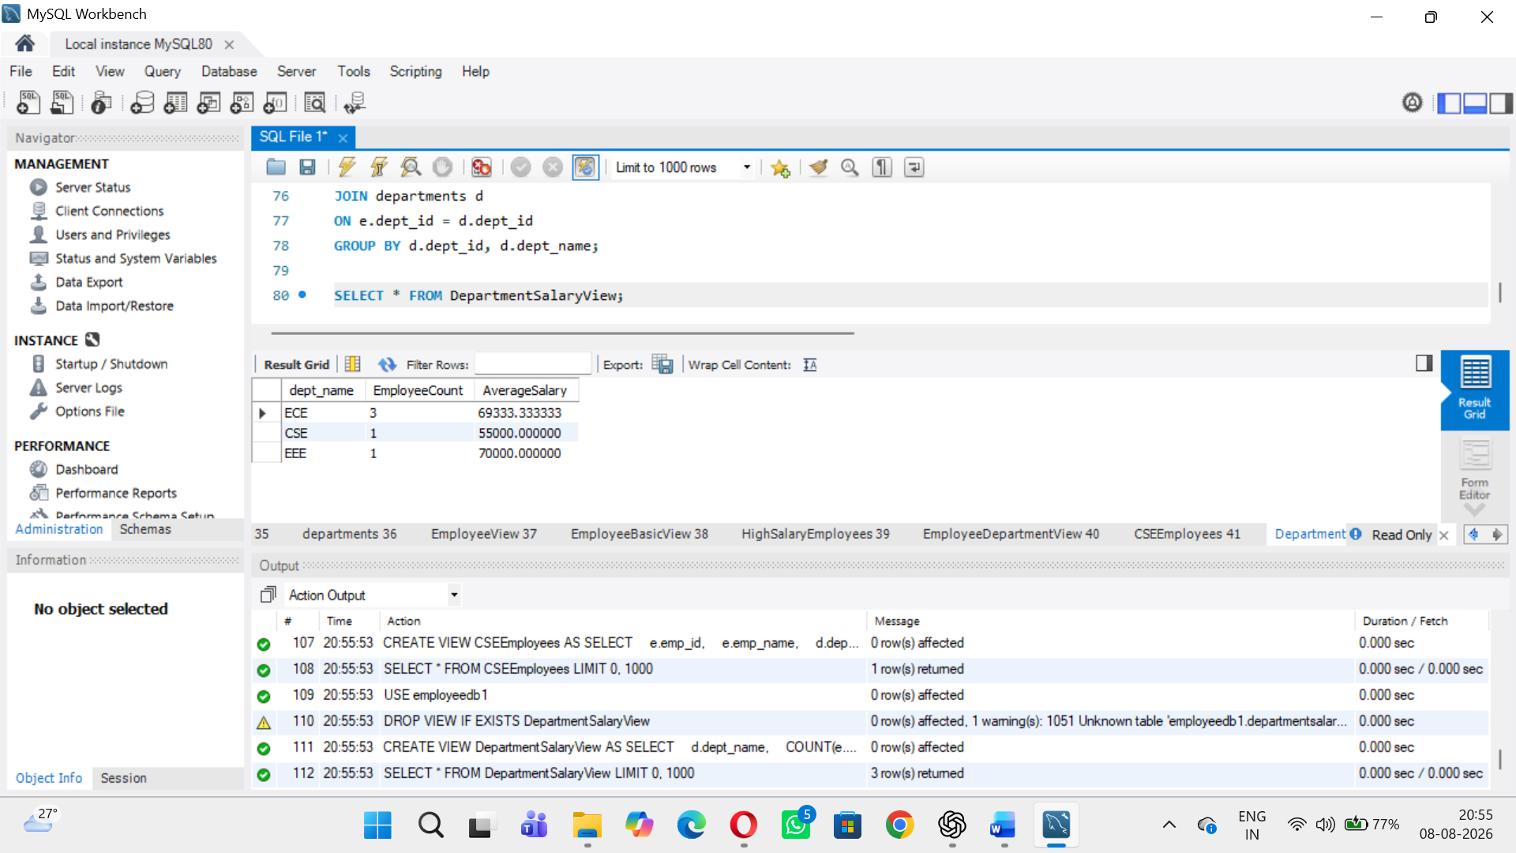
View 7 – Departments with Average Salary Above 55000
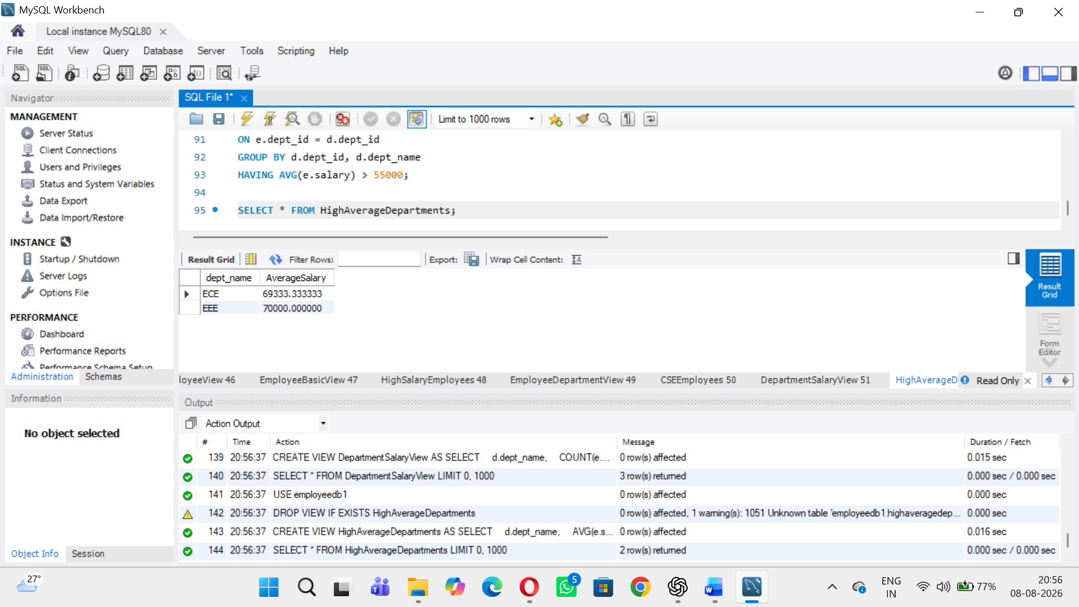
View 8 – Salary Range View
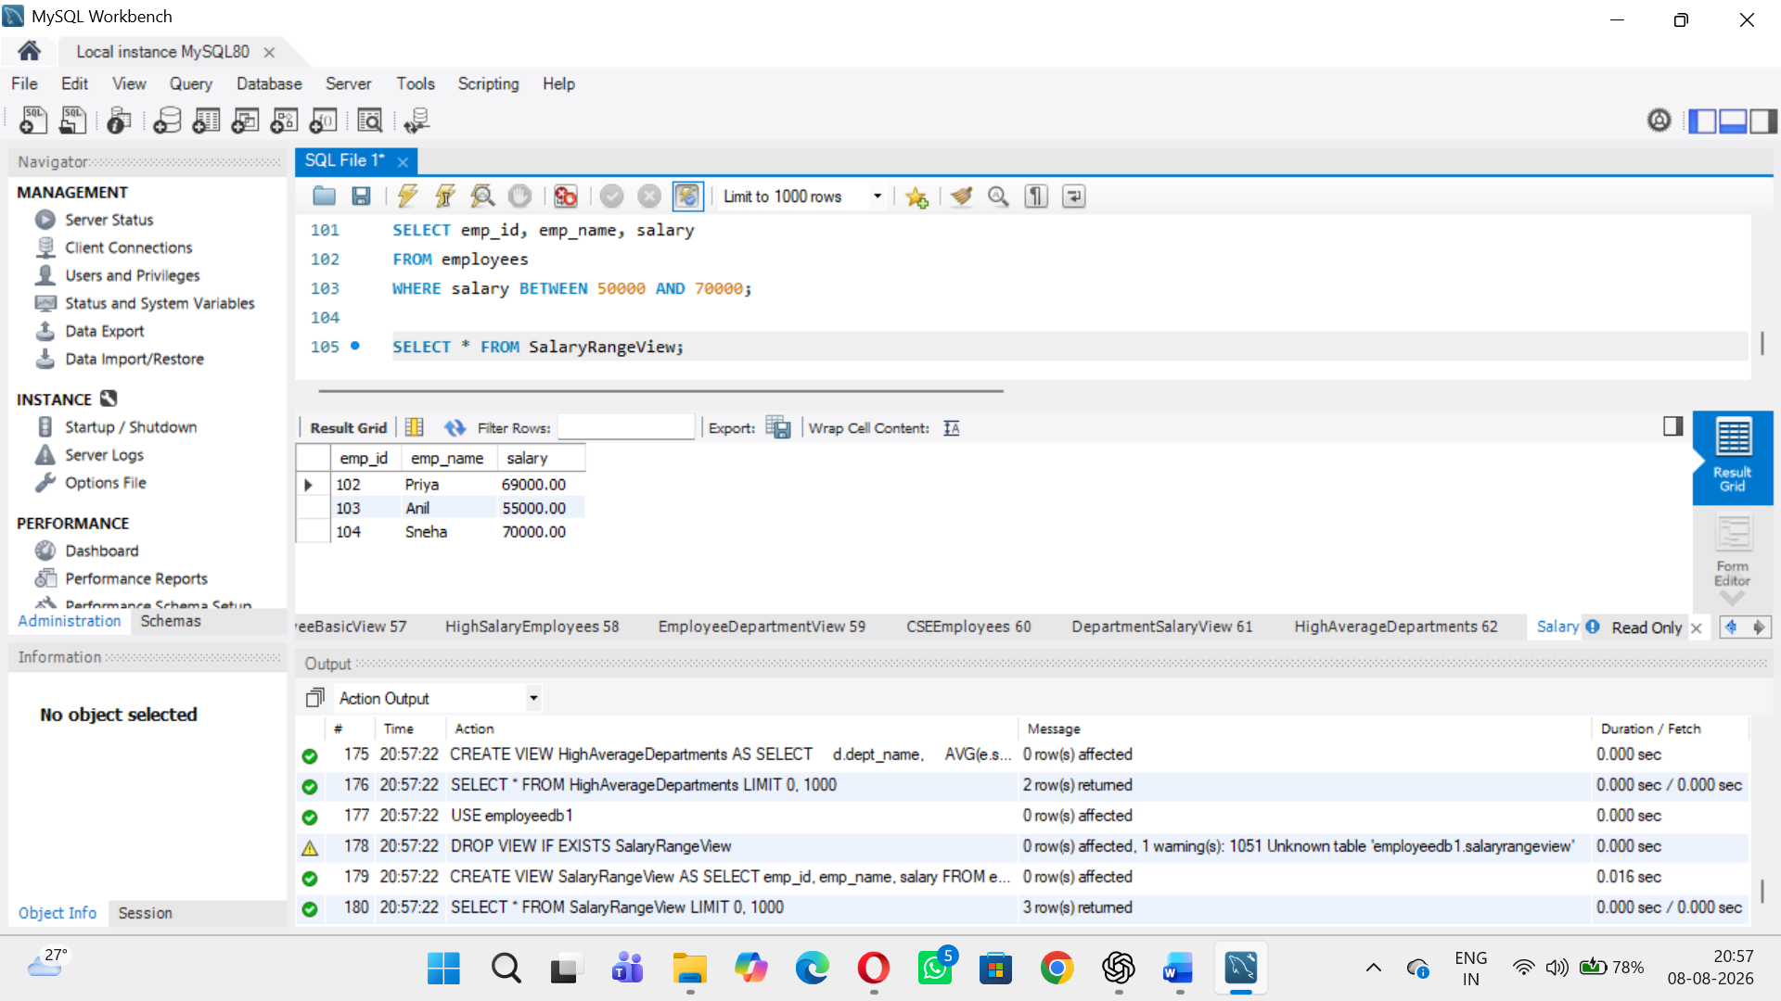
View 9 – View with Calculated Column
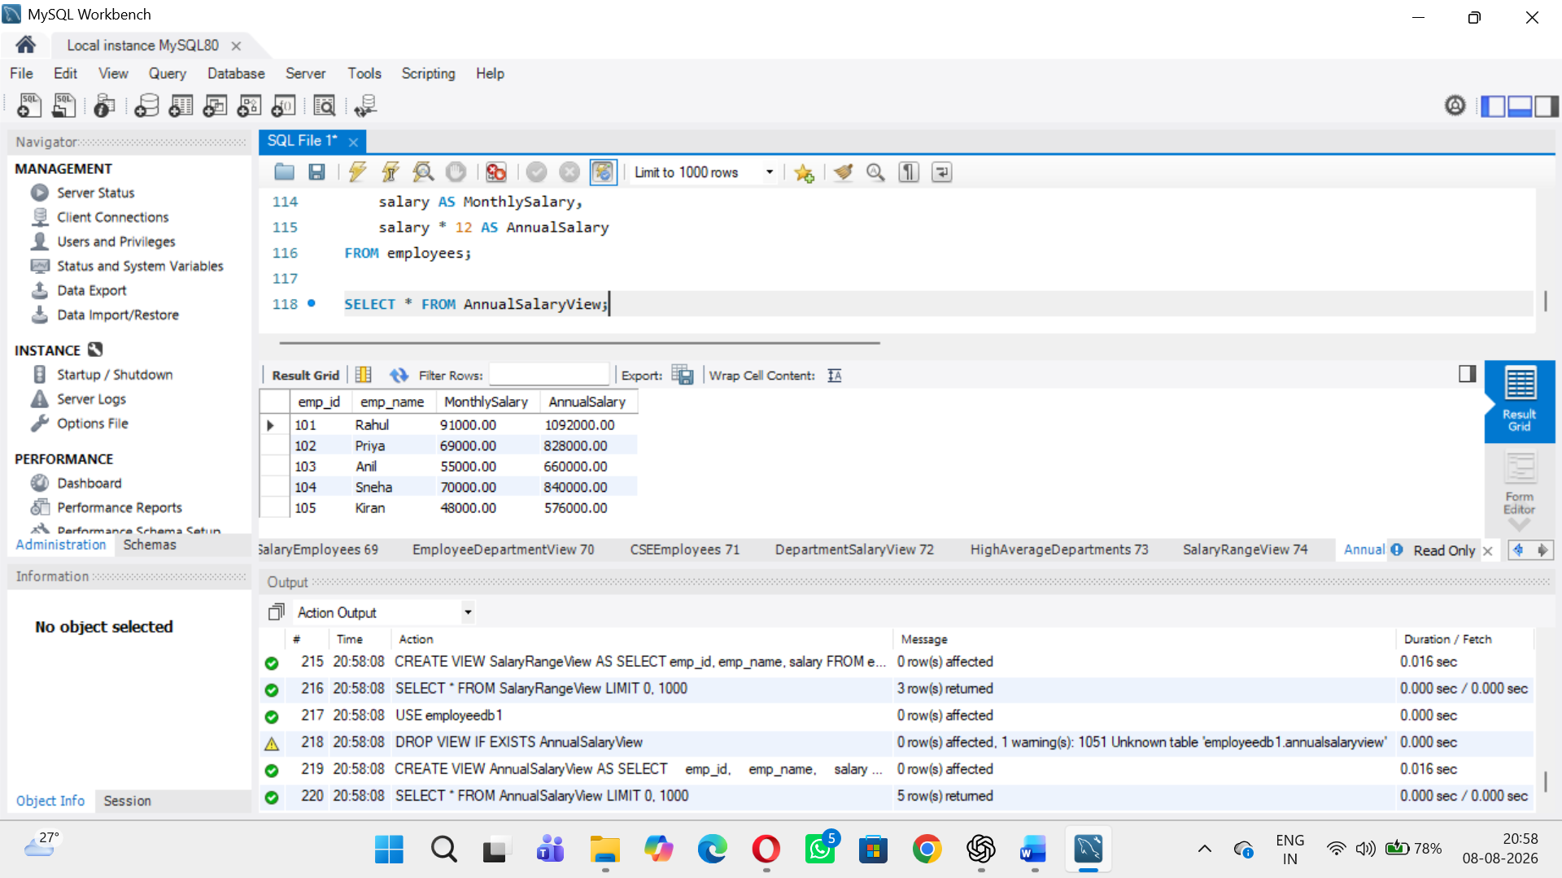
View 10 – Update Data Through a Simple View
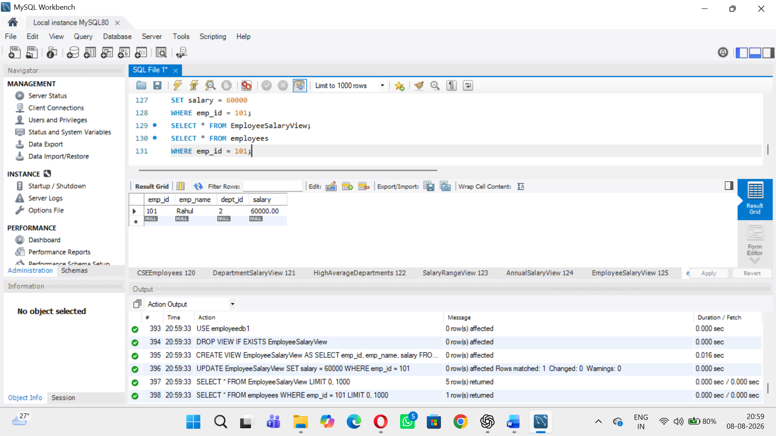
View 11 – CREATE OR REPLACE VIEW
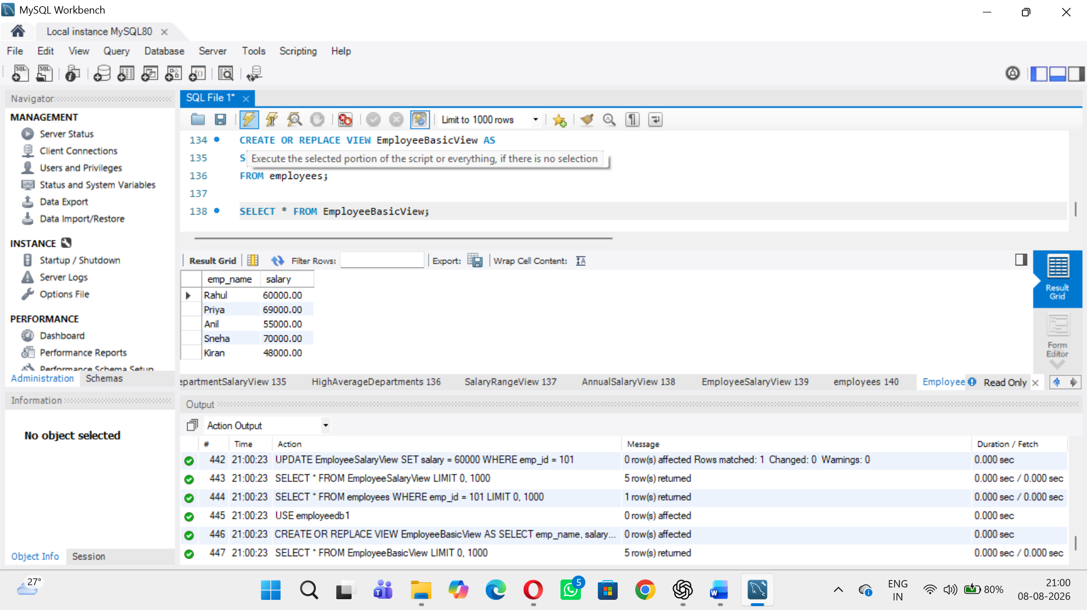
View 12 – View Definition
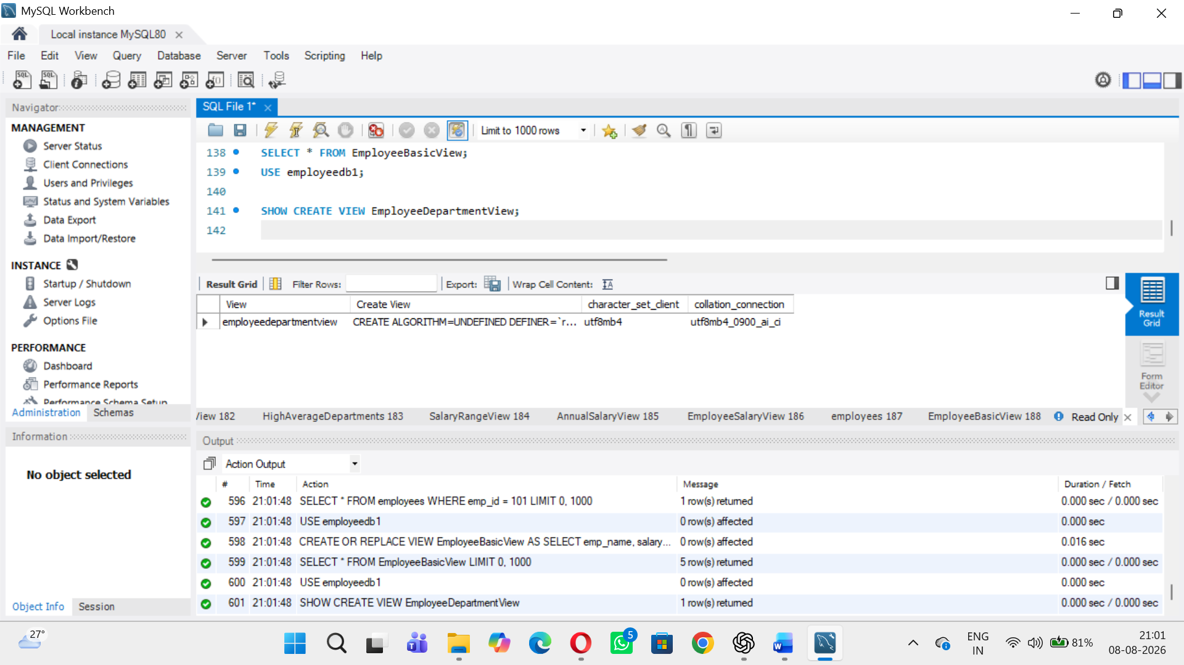
View 13 – List All Views
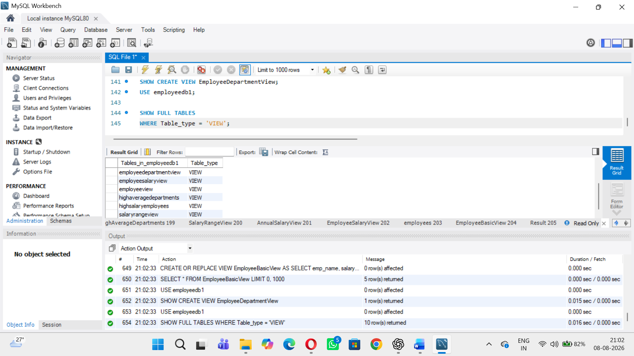
View 14 – Drop a View
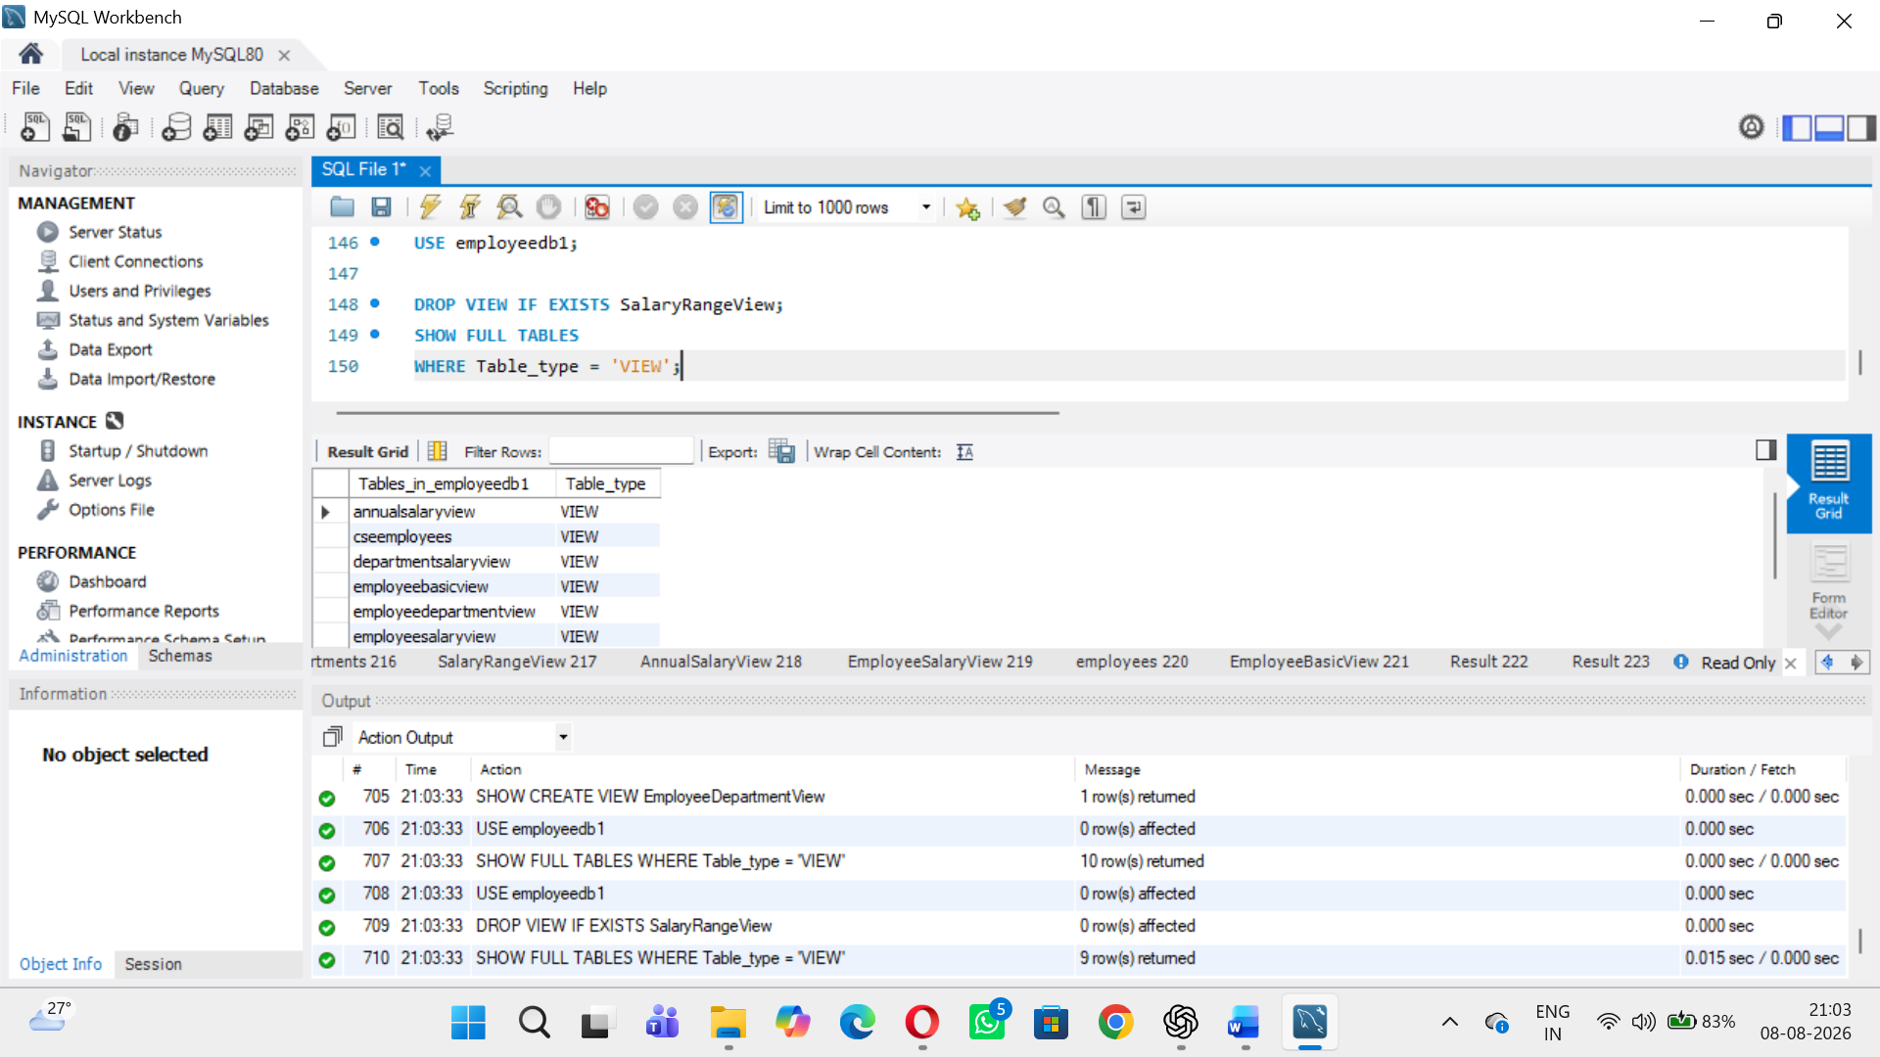
Student Practice Tasks
1. Create a View showing only emp_id, emp_name and salary.
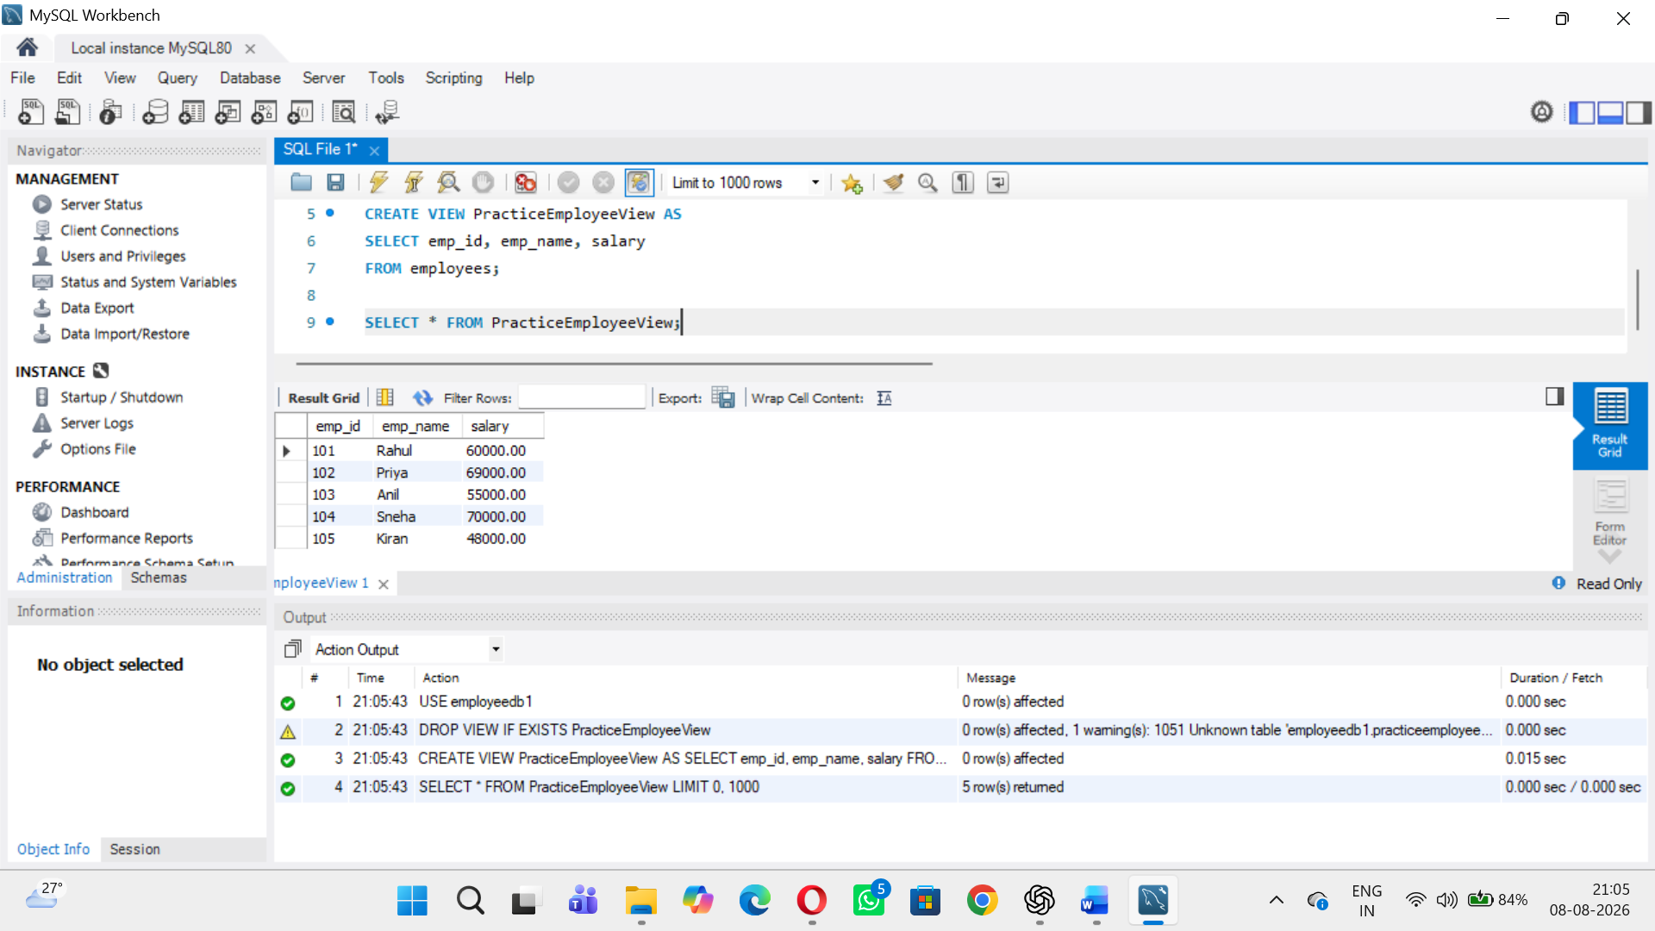
2. Create a View for employees earning more than 60000.
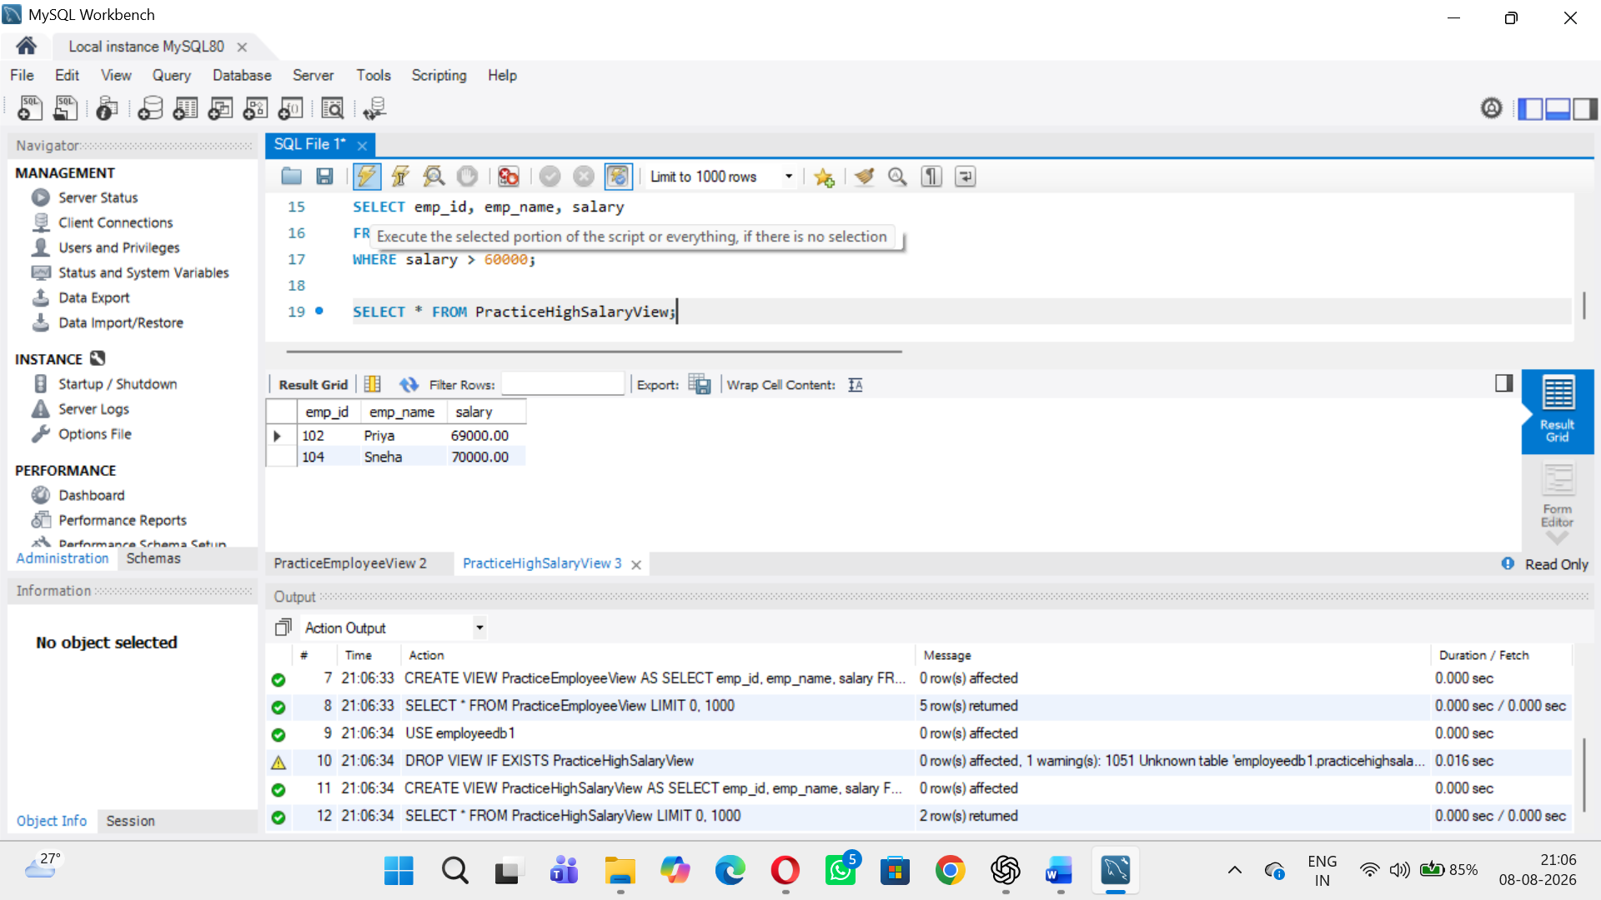

3. Create a View showing employee name, department name and salary using JOIN.
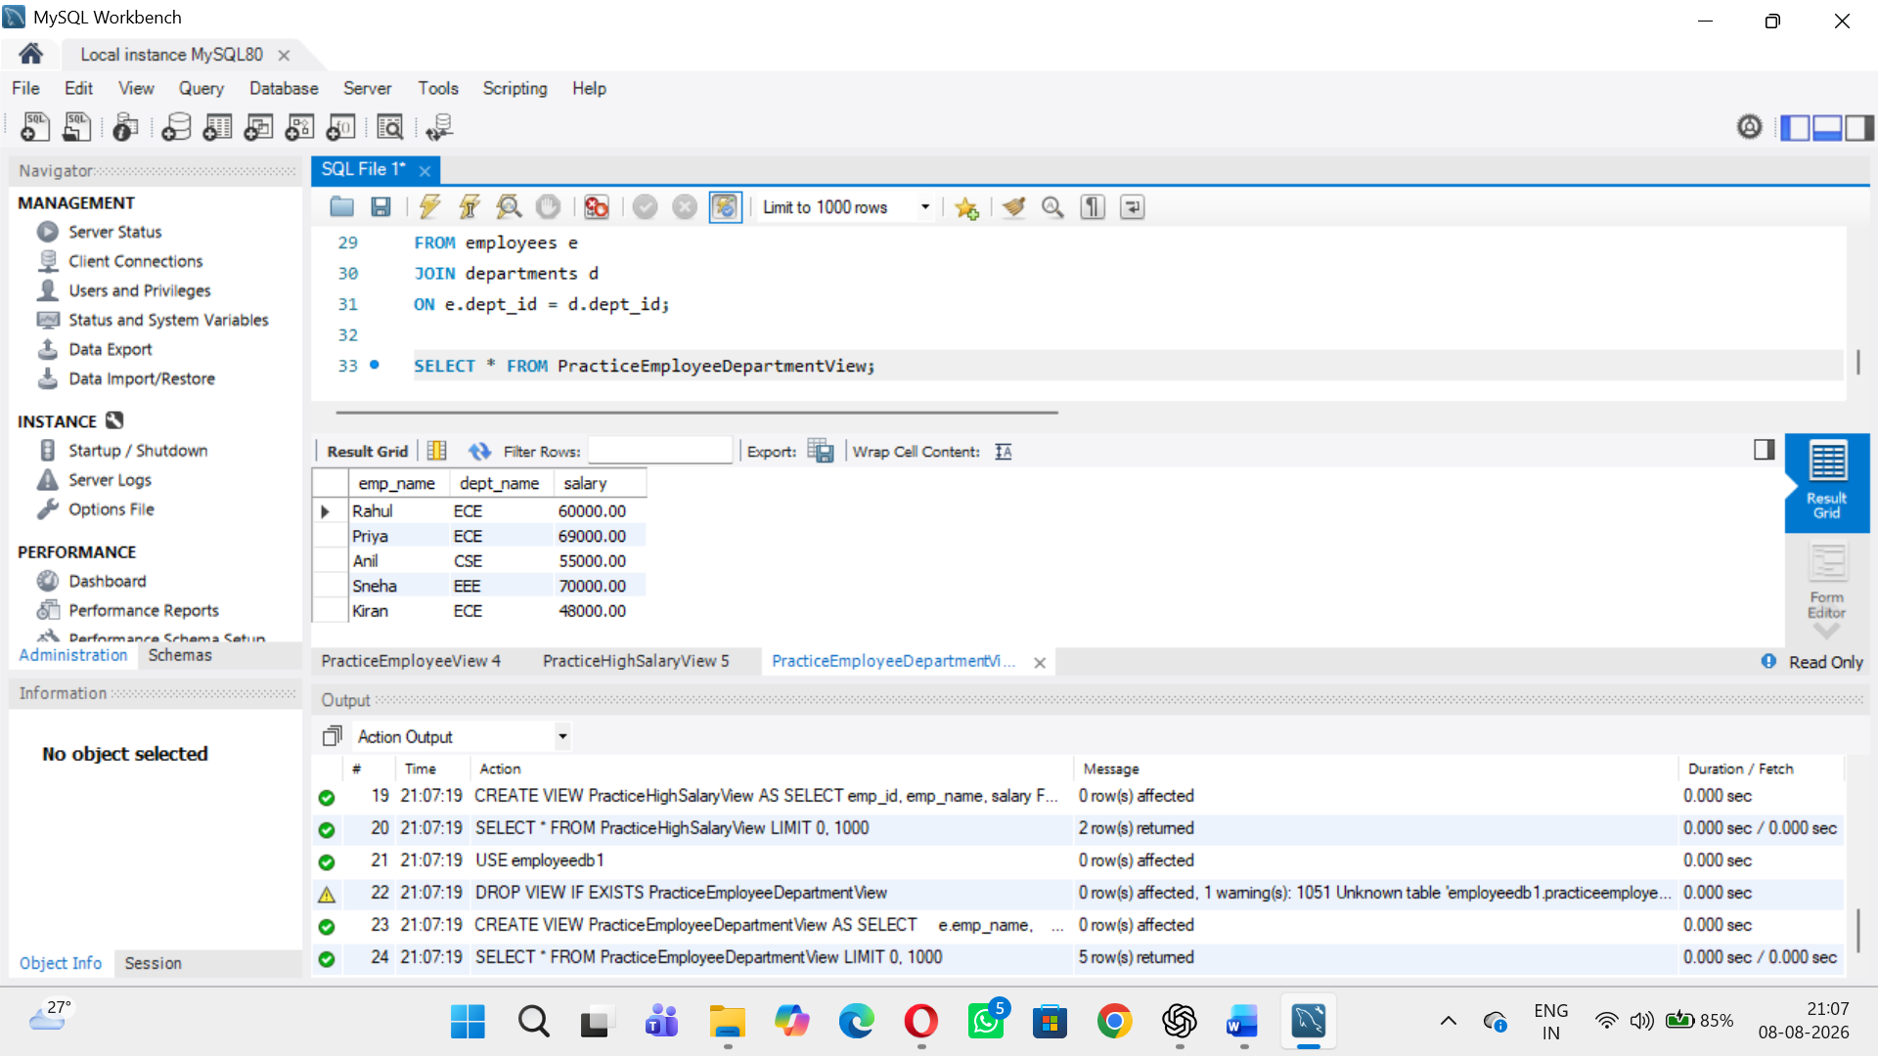
4 Create a View showing only ECE employees.
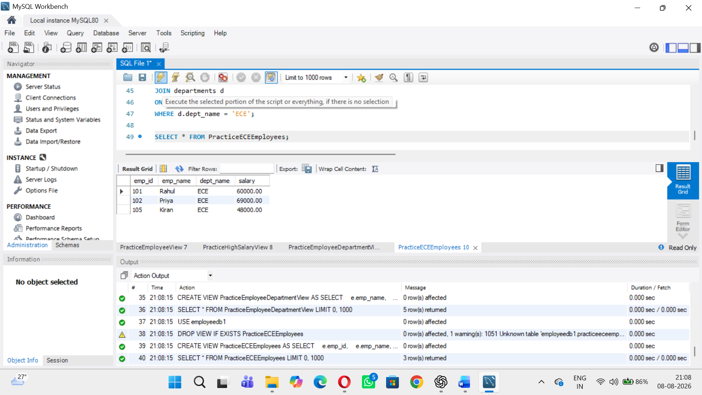
5 Create a View showing department-wise employee count.
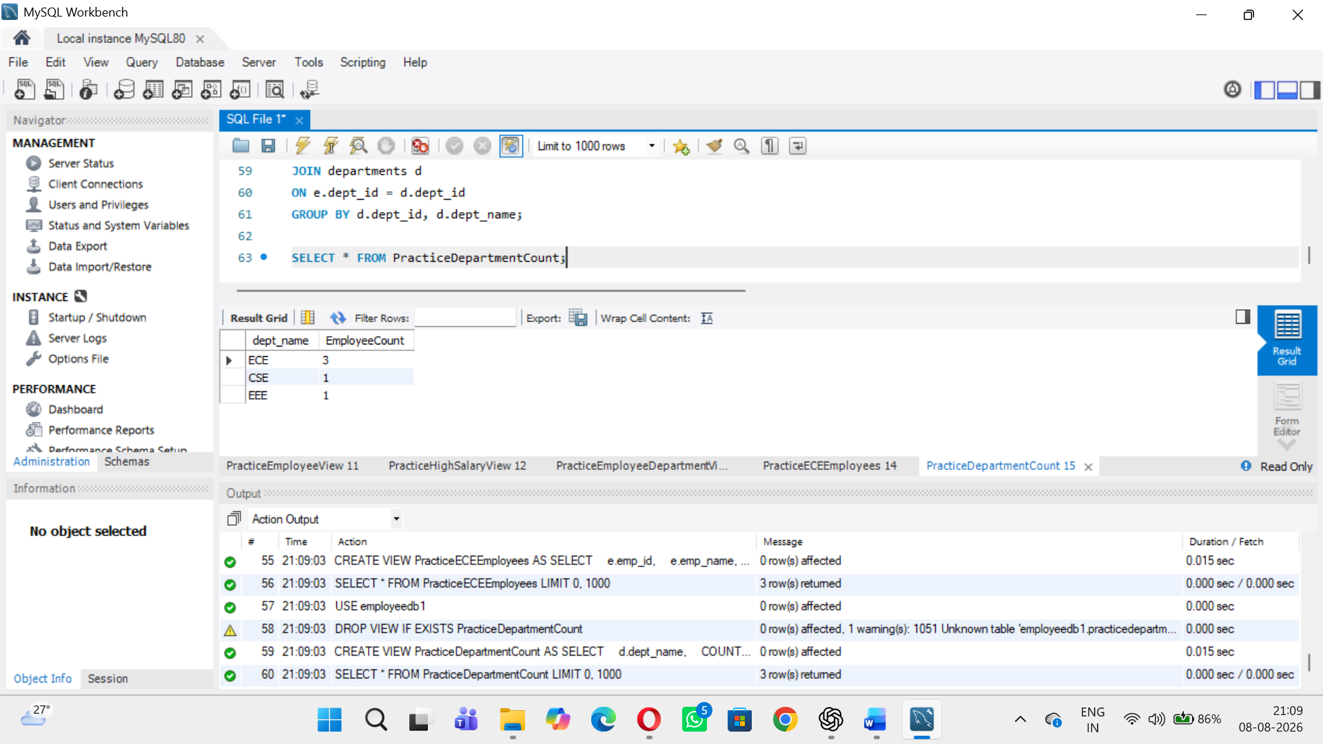
6. Create a View showing department-wise maximum salary.
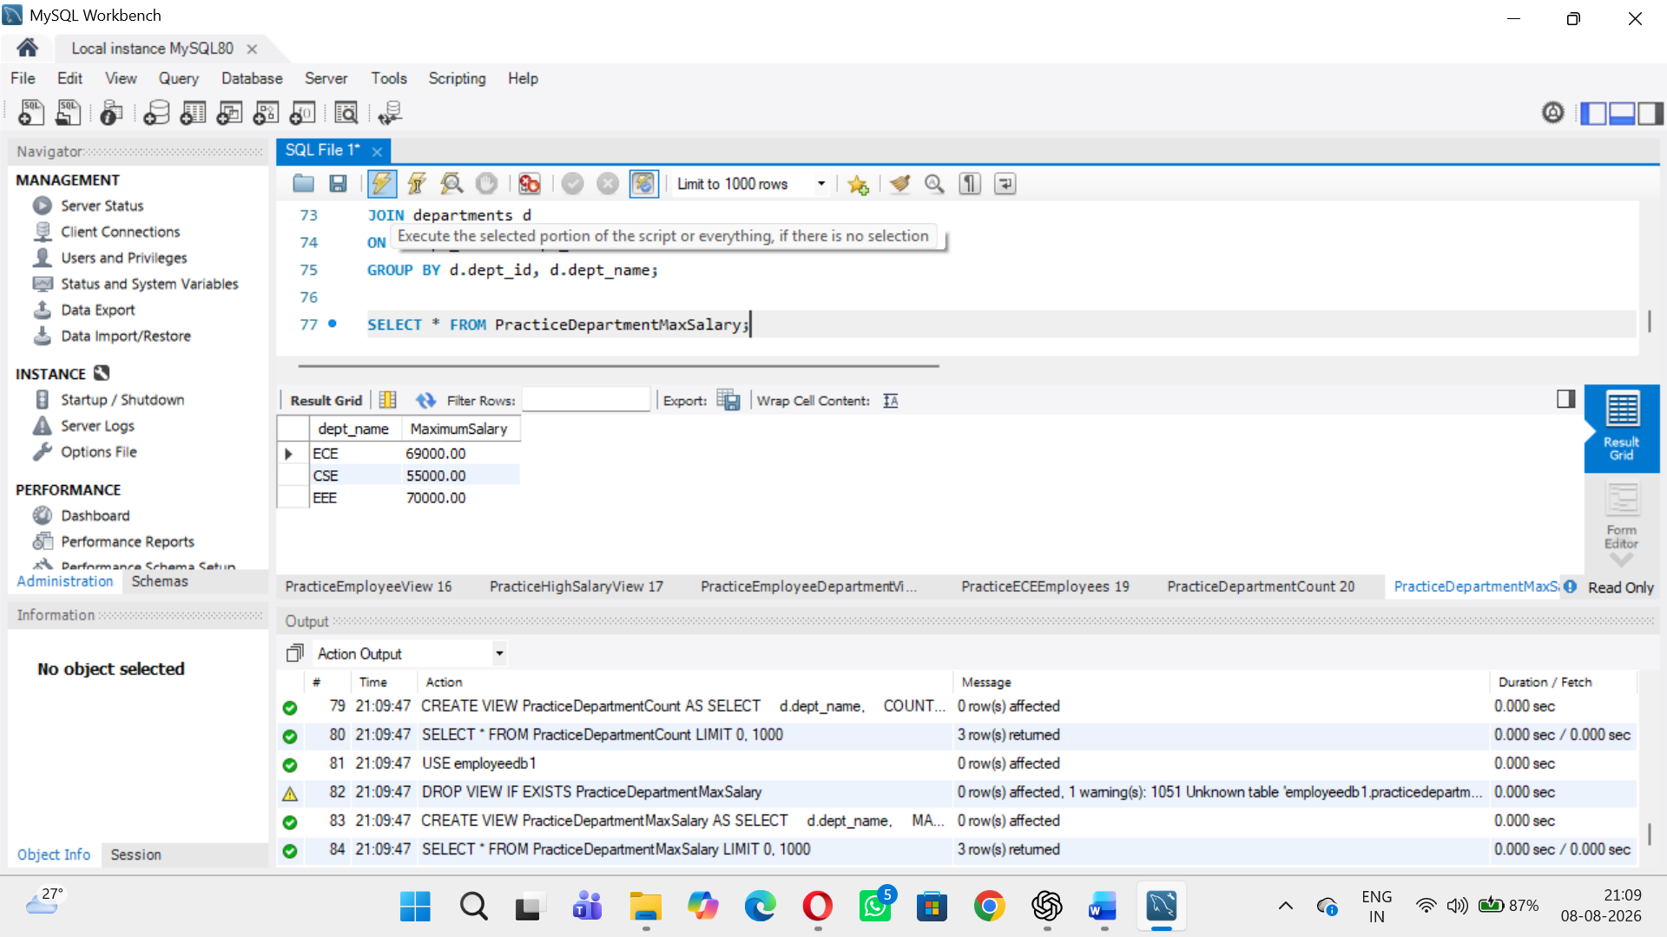
7. Create a View showing departments whose average salary is greater than 50000.
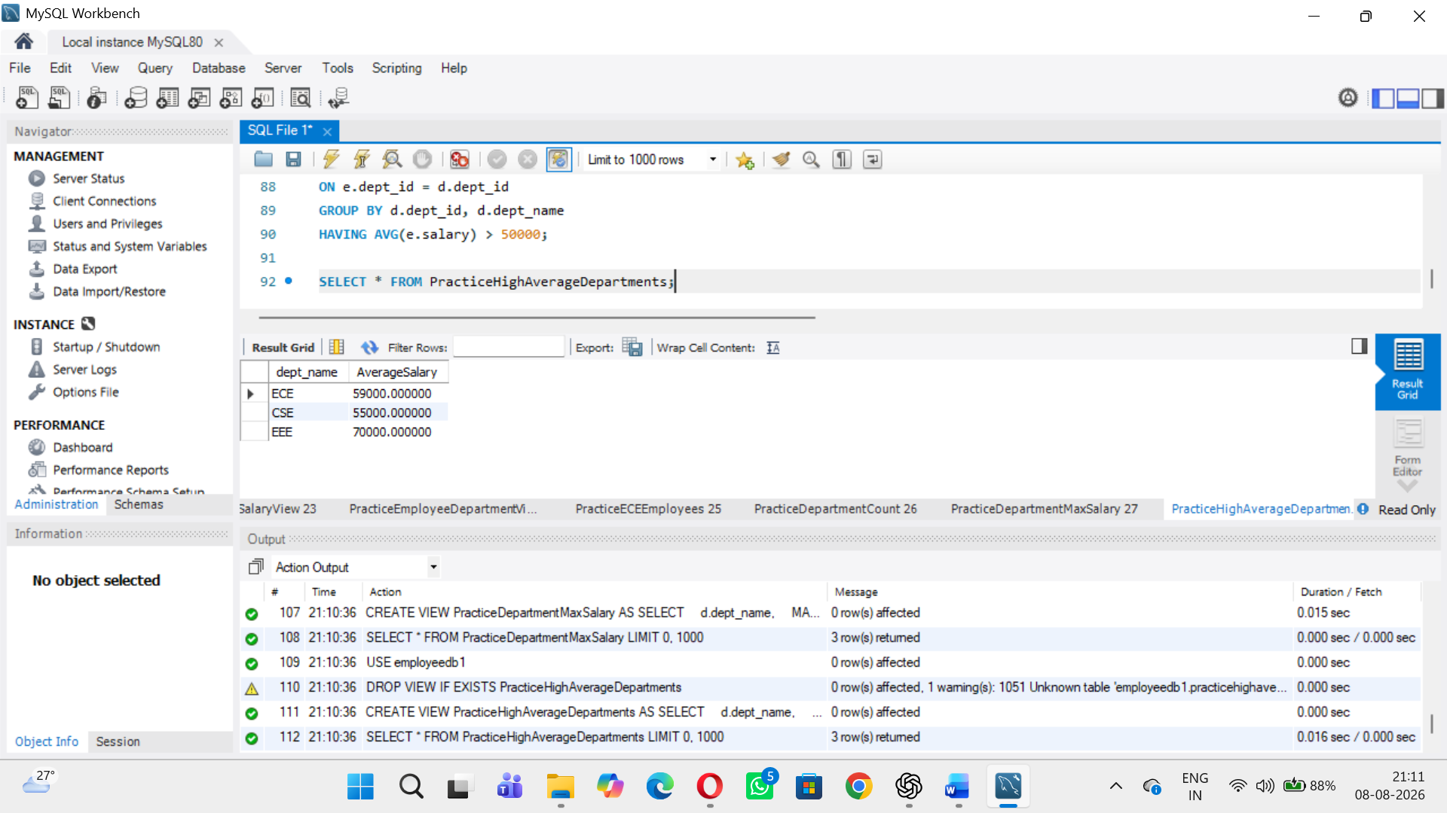
8. Create a View with employee name, salary and annual salary.
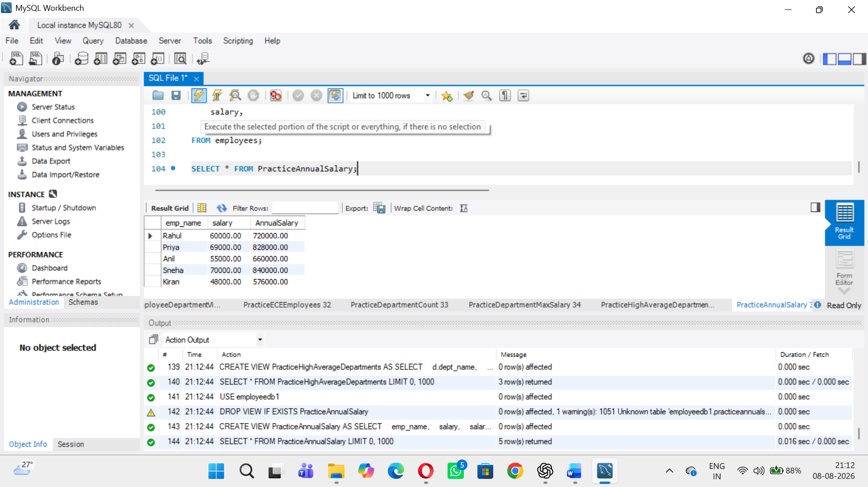
9. Update an employee's salary through a simple View and verify the base table.
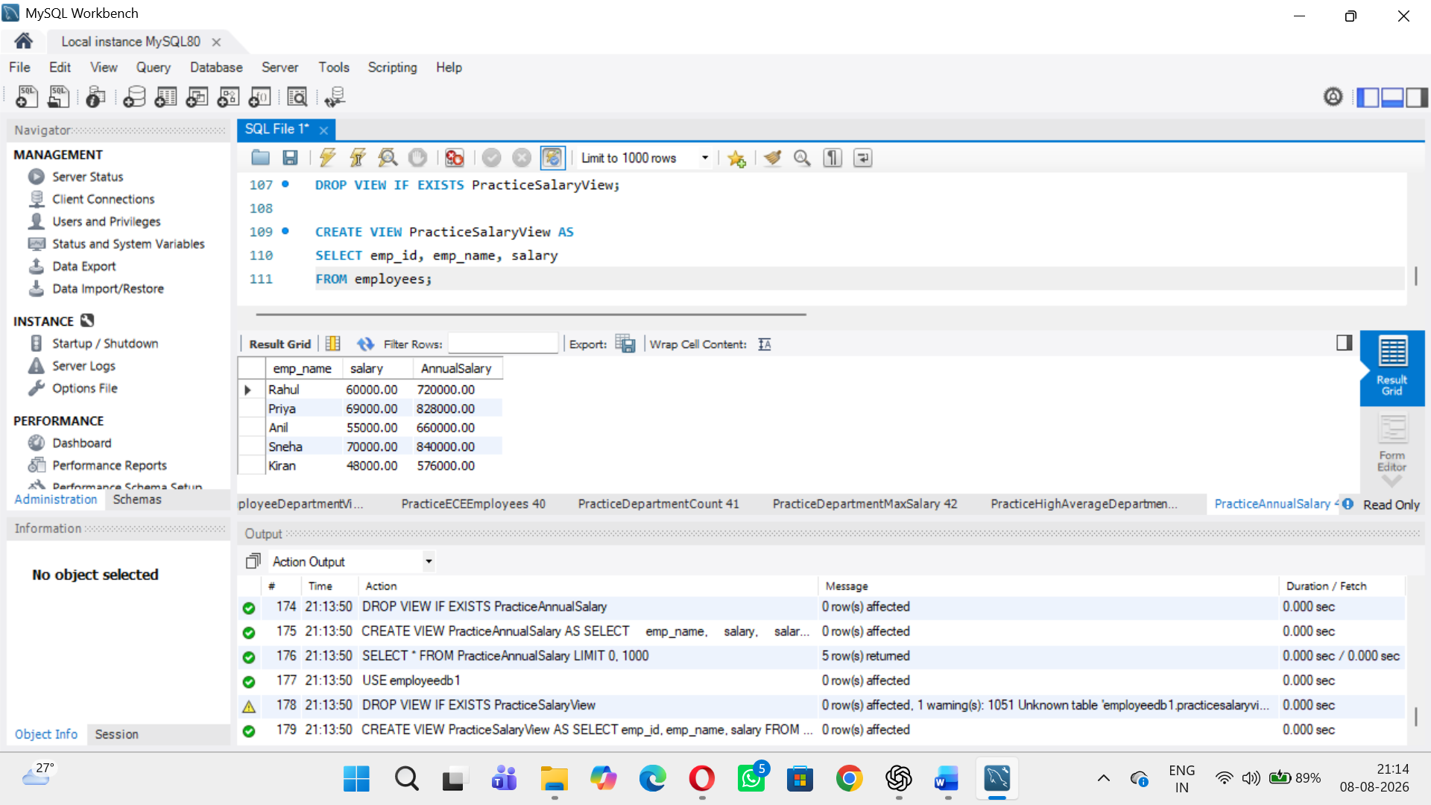
10. Use SHOW CREATE VIEW to display the definition of a View.
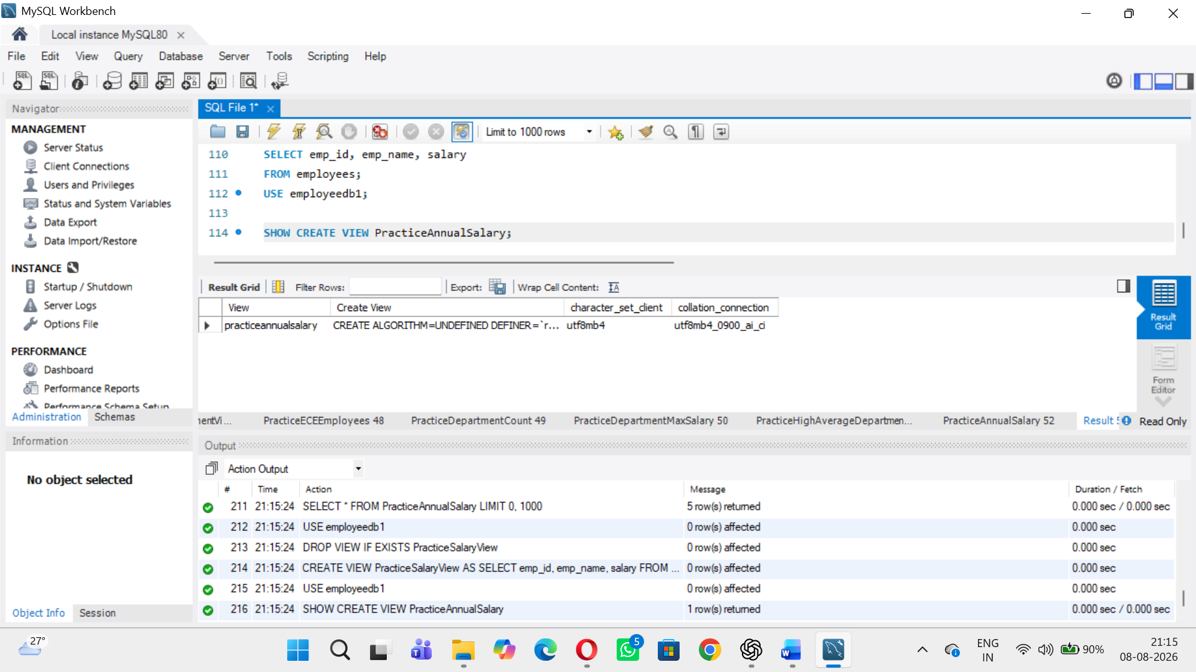
11. List all Views in the database.
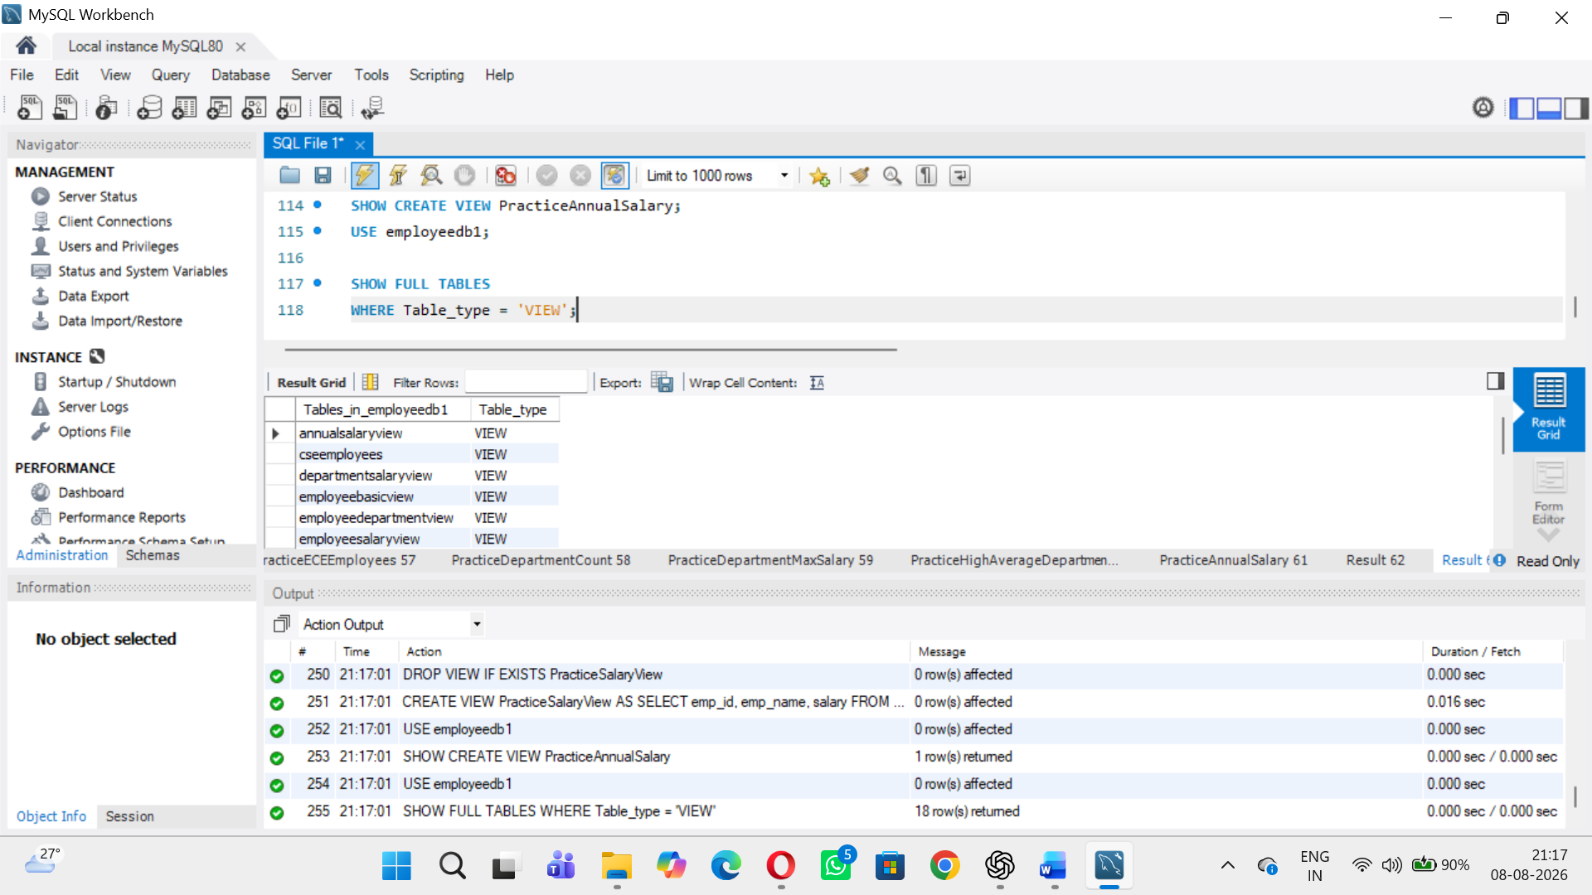
12. Drop a View and verify that it no longer appears in the list.
